**Detail Business Requirements Document**

**Mobile Freight Tracking Experience**

Prepared by: Fathima Thotathil

Date Created: 2014-JUN-16

Last Revision Date: 2014-JUNE-24

Date Submitted for Approval: N/A

Version Number: 1.1

**Document Log History**

| **Date** | **Version** | **Author** | **Description of Change** | **Sections Impacted** |
| --- | --- | --- | --- | --- |
| 2014-JUN-16 | 1.0 | Fathima Thotathil | Initial version | N/A |
| 2014-JUN-21 | 1.1 | Fathima Thotathil | Included fields, business processes, screenshots | N/A |
| 2014-JUN-24 | 1.2 | Fathima Thotathil | Included business process diagrams and updated steps. | N/A |
|  |  |  |  |  |

**Business Resources**

**Mash Logistics**

| **Role** | **Last Name** | **First Name** | **Business Area /Department** | **Reviewer** | **Approver** |
| --- | --- | --- | --- | --- | --- |
| Business Sponsor | Khan | Maqdoom | Director of Administration |  |  |
| Business SME | Ahmed | Arfeen | District Manager and CORVI Coordinator |  |  |

**Motion 9 Studios**

| **Role** | **Last Name** | **First Name** | **Business Area/Department** | **Reviewer** | **Approver** |
| --- | --- | --- | --- | --- | --- |
| Project Manager | Thotathil | Fathima | Business Analysis and Architect |  |  |

**External Project Participants**

| **External Project Participants** | **Title** | **Last Name** | **First Name** | **Contact**  **Information** | **Reviewer** | **Approver** |
| --- | --- | --- | --- | --- | --- | --- |
| Kale Logistics | CORVI Consultant | Master | Nitin | Nitin.master@kalelogistics.in |  |  |

Contents

I. Introduction 5

A. Background 5

B. Project Goals and Objectives 5

C. Key Benefits 5

D. Assumptions 6

E. Dependencies 6

F. Relevant Facts 6

II. Summary of Scope 7

Business Capabilities 7

In-Scope 7

Out-Of-Scope 7

Business Processes 7

In-Scope 7

Out-of-Scope 7

Business Use Cases 8

In-Scope 8

Out-Of-Scope 8

III. Freight Tracker 9

Business Use Case 9

Ability for customers to view Freight status 9

Application Use Cases 10

Login to Freight Tracker 10

View Customer orders 12

Data Definition 16

IV. Freight Updater 17

Business Use Cases 17

Ability for vendor to update Freight status 17

Application Use Cases 18

Login to Freight Updater 18

View assigned freights 20

Data Definition 24

V. Non Functional Requirements 25

Non-Functional Requirements List 25

(Need more information – have sent Questionnaire) 25

VI. Business Rules List 25

Not identified yet 25

VII. Information Usage Requirements 26

VIII. Design Considerations 26

IX. Testing Considerations 26

Appendix 27

G. Glossary of Terms and Acronyms 27

H. Release Planning 28

I. Traceability 28

J. Freight forwarding process (Import or Export) 29

K. Shipment statuses displayed in Freight Tracker mobile application 30

L. Shipment statuses displayed in Freight Updater mobile application 31

# Introduction

1. Background

Mash Logistics is one of the innovative logistics companies in Saudi Arabia that  reaches out to provide comprehensive logistics solutions. Most of their customers are commercial establishments. They provide both export and import services (90% import services). See Appendix J for Freight forwarding process of Mash Logistics.

Mash Logistics is facing the following challenges:

* Difficulty in tracking freight status from vendors.
* Manually provide customer’s freight status.
* Unable to provide order history to customers.

1. Project Goals and Objectives

The objective of Mobile Freight Tracking Experience (MFTE) is to:

* Provide real time freight tracking information to Mash Logistics’ customers on iOS and Android using Freight Tracker mobile app.
* Provide Mash Logistics’ vendors to update freight status on iOS and Android using Freight Updater mobile app.

1. Key Benefits

Meeting the project objectives should result in delivery of the following benefits:

* User friendly interface
* Enhance customer satisfaction
* Eliminate paper work
* Reduce manual operations
* Increase operation efficiency
* Reduce operation costs
* Increase employee productivity
* Increase profits

1. Assumptions

|  |  |
| --- | --- |
| **Description** | **Type** |
| Freight Tracker and Freight Updater mobile applications should be available in the Apple app store,Google play store and Mash website for Mash Logistics customers and vendors to download and install respectively. | Assumption |
| Login credentials to login to Freight Tracker and Freight Updater mobile applications will be provided by Mash Logistics to their customers and vendors. | Assumption |
| Mash Logistics will be able to assign freights to vendors when an order is placed by customer. | Assumption |

1. Dependencies

|  |  |
| --- | --- |
| **Description** | **Type** |
| Freight Tracker and Freight Updater mobile applications will be accessing CORVI ERP for data through Web API provided by Kale Logistics | Dependency |

1. Relevant Facts

|  |
| --- |
| **Description** |
| NA |

# Summary of Scope

## Business Capabilities

### In-Scope

| **Business Capability** | **Capability**  **Added / Changed**  **Since SOW?** |
| --- | --- |
| Ability for customers to view Freight status | No |
| Ability for vendor to update Freight status | No |

### Out-Of-Scope

|  |  |
| --- | --- |
| **Description** | **Reason** |
| N/A | N/A |
|  |  |

## Business Processes

### In-Scope

| **Business Process** | **Business Capability** | **Business Process**  **Added / Changed**  **Since IA?** |
| --- | --- | --- |
| Automate Freight Tracking Process | * Ability for customers to view Freight status * Ability for vendor to update Freight status | No |
|  |  |  |
|  |  |  |

### Out-of-Scope

No out of scope business processes identified

## Business Use Cases

### In-Scope

| **Business Use Case** | **Business Process** | **Business Capability** | **Use Case**  **Added / Changed**  **Since IA?** |
| --- | --- | --- | --- |
| Ability for customer to track freight status | Automate Freight Tracking Process | Ability for customer to track freight status | No |
| Ability for vendor to update freight status | Ability for vendor to update freight status | No |

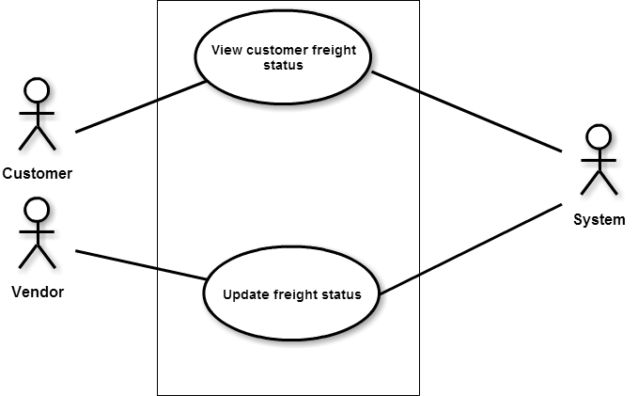

### Out-Of-Scope

Not applicable

# Freight Tracker

Business Use Case

Ability for customers to view Freight status

Description

|  |  |  |  |  |  |  |
| --- | --- | --- | --- | --- | --- | --- |
| **Use Case Identifier** | BUC-001 | | | | | |
| **Use Case Type** | Business Use Case | | | | | |
| **Use Case Goal** | Ability for customers to view Freight status | | | | | |
| **Use Case Goal Level** |  | Summary |  | User Goal |  | SubFunction |
| **Actor(s)** | Mash Logistic Customer [Primary Actor] | | | | | |
| **Triggering Event(s)** | Customer accesses Freight Tracker to view Freight status | | | | | |
| **Pre-Condition(s)** | Customer has already installed Freight Tracker app from App store or Google play store or Mash website | | | | | |
| **Success End Condition(s)** | Customer views his/her freight statuses | | | | | |
| **Failed End Condition(s)** | Customer is not able to view his/her freight statuses | | | | | |

|  |  |
| --- | --- |
| **Summary Narrative** | Customer accesses Freight Tracker mobile application using the credentials provided by Mash Logistics. The mobile app displays all the freights (past and current orders) related to the customer. Customer can view detailed information of selected freight. |

Primary Scenario

|  |  |  |
| --- | --- | --- |
| **Description** | | **Change**  **(Y/N)** |
| **1** | Customer logs in to Freight Tracker mobile application | N |
| **2** | Customer views list of freights (past and current orders) shipped through Mash Logistics | N |
| **3** | Customer views detail information of selected Freight | N |
| **4** | Customer logs out of Freight Tracker mobile application | N |

Supplemental Information

|  |  |
| --- | --- |
| **Application(s) Expected to be used by Actor** | Freight Tracker Mobile Application |
| **Business Capability** | Ability for customers to view Freight Status |

Application Use Cases

Login to Freight Tracker

Description

|  |  |  |  |  |  |  |
| --- | --- | --- | --- | --- | --- | --- |
| **Use Case Identifier** | AUC-001 | | | | | |
| **Use Case Type** | Application Use Case | | | | | |
| **Use Case Goal** |  | Summary |  | User Goal |  | SubFunction |
| **Actor(s)** | Mash Logistics Customer | | | | | |
| **Pre-Condition(s)** | Customer has already installed Freight Tracker app from App store or Google play store or Mash website | | | | | |
| **Triggering Event(s)** | Customer accesses Freight Tracker to view Freight status | | | | | |
| **Success End Condition** | Customer is able to successfully login to Freight Tracker app | | | | | |
| **Failed End Condition** | Customer is not able to successfully login to Freight Tracker app | | | | | |

|  |  |
| --- | --- |
| **Summary Narrative** | Customer has already downloaded/installed the Freight Tracker application in their iPhone/iPad/Android. Customer would like to access the Freight Tracker app to track freight status. Customer selects the Freight Tracker app icon on the home screen of the device. The login screen of the application is displayed and prompts the user to enter username and password. The username and password are provided by Mash Logistics to the customer. If the correct combination of username and password are entered, the customer will be able to successfully login to the application. If the combination of username and password is incorrect, the customer will not be able to login to the application. The customer could get in touch with Mash Logistics agent through the app using Quick Call feature. |

Primary Scenario

|  |  |  |
| --- | --- | --- |
| **Step** | **Description** | **Chg. (Y/N)** |
| **1** | Customer selects the Freight Tracker app on the home screen of his/her iPhone/iPad/Android. | N |
| **2** | Customer views the login screen and is prompted to enter the username and password to login. | N |
| **3** | Customer enters the username | N |
| **4** | Customer enters the password | N |
| **5** | Customer submits the information | N |
| **6** | If the login credentials are correct, customer successfully logs in to the application. |  |

Alternate Scenario (1)

|  |  |  |
| --- | --- | --- |
| **Step** | **Description** | **Chg. (Y/N)** |
| **1** | Customer selects the Freight Tracker app on the home screen of his/her iPhone/iPad/Android. | N |
| **2** | Customer can get in touch with Mash Logistics Agent with the Quick Call feature if required. | N |
| **3** | Customer select Quick call option. | N |
| **4** | App initiates a Phone call to Mash Logistic Agent | N |

Alternate Scenario (2)

|  |  |  |
| --- | --- | --- |
| **Step** | **Description** | **Chg. (Y/N)** |
| **1** | Customer selects the Freight Tracker app on the home screen of his/her iPhone/iPad/Android. | N |
| **2** | Customer views the login screen and is prompted to enter the username and password to login. | N |
| **3** | Customer enters the username | N |
| **4** | Customer enters the password | N |
| **5** | Customer submits the information | N |
| **6** | If the login credentials are incorrect, customer will not be able to log in to the application. A message is displayed “ Please contact Mash Logistics” | N |
| **7** | Customer can get in touch with Mash Logistics Agent with the Quick Call feature if required. | N |
| **8** | Customer select Quick call option. | N |
| **9** | App initiates a Phone call to Mash Logistic Agent | N |

Supplemental Information

|  |  |
| --- | --- |
| **Application(s) Expected to be used by Actor** | Freight Tracker Mobile Application |
| **Business Capability** | Ability for Customer to view Freight Status |

Login

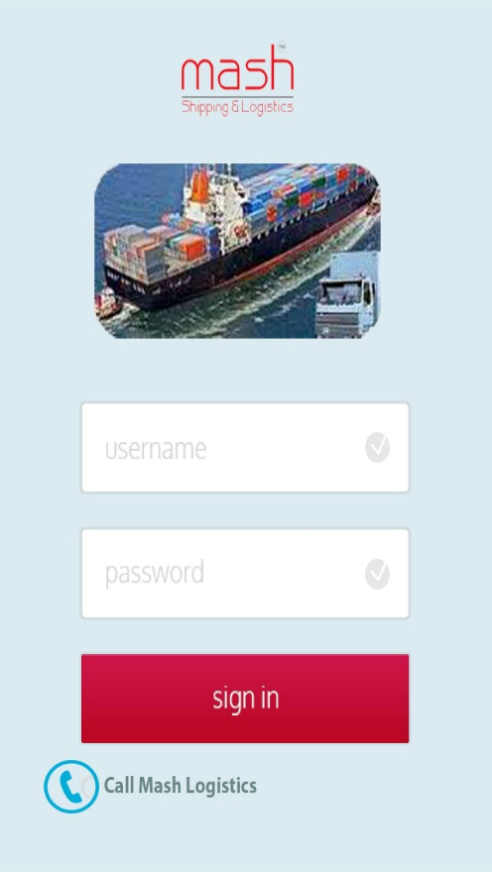

View Customer orders

Description

|  |  |  |  |  |  |  |
| --- | --- | --- | --- | --- | --- | --- |
| **Use Case Identifier** | AUC-002 | | | | | |
| **Use Case Type** | Application Use Case | | | | | |
| **Use Case Goal** |  | Summary |  | User Goal |  | SubFunction |
| **Actor(s)** | Mash Logistics Customer | | | | | |
| **Pre-Condition(s)** | Customer has already logged in to the Freight Tracker app | | | | | |
| **Triggering Event(s)** | Customer accesses Freight Tracker app to view Freight status | | | | | |
| **Success End Condition** | Customer is able to successfully view his/her freights | | | | | |
| **Failed End Condition** | Customer is not able to successfully view his/her freights | | | | | |

|  |  |
| --- | --- |
| **Summary Narrative** | Customer has already logged in to the Freight Tracker application. Customer views his/her freights in list view. For each freight, customer views the details in the list view. If customer wishes to view details of each freight, he/she can select view details. The customer is then navigated to view the details of the selected freight. If the customer would like to view the status history, the customer can select option to view status history. Details which are not available will be displayed as ‘NA’. |

Primary Scenario

|  |  |  |
| --- | --- | --- |
| **Step** | **Description** | **Chg. (Y/N)** |
| **1** | System identifies all the orders placed by the customer based on the login credentials. | N |
| **2** | Sytem sorts the list of shipments based on Mash Logistics Job No. | N |
| **3** | System displays sorted orders in list view to the customer with the following information.   * Mash Logistics Job No * Purchase Order No/Consignee Reference No/ Shipper Reference No (Whichever is available. If all three numbers are available, then Purchase Order No will be displayed) * Status (Last status only will be displayed) * Estimated Time of Departure (ETD) * Estimated Time of Arrival (ETA) | N |
| **4** | Customer can select view shipment details if he/she wishes to view detailed information each order | N |
| **5** | On selecting view details, customer is the navigated to the details page. | N |
| **6** | System displays the details of the selected order/shipment. | N |
| **7** | The details of the shipment are as follows:   * Mash Logistics Job No * Purchase Order No * Consignee Reference No * Shipper Reference No * Airway Bill No (if mode of shipment is air) * Bill of Lading (if mode of shipment is sea) * Status of the shipment (History of all statuses for this shipment will be displayed if the customer selects the option to view status history details. See appendix K for more details) * No of pieces/container depending upon shipment mode (air, sea respectively) * Total Weight * Total CBM (cubic meter) * Estimated Time of Departure * Estimated Time of Arrival * Actual arrival at Destination * Invoice Amount (if invoiced ) | N |

Alternate Scenario(s)

|  |  |  |
| --- | --- | --- |
| **Step** | **Description** | **Chg. (Y/N)** |
| **1** | Customer may choose to go to the list view page where he can view a summary of all the shipments from the details page by selecting the ‘Back’ option | N |
| **2** | Customer may choose to logout of the application from the list view page or from the details page | N |
| **3** | Customer may choose to get in touch with Mash Logistics customer agent by selecting the ‘Quick Call’ option | N |
| **4** | Customer selects Quick call option. | N |
| **5** | App initiates a Phone call to Mash Logistic Agent. | N |

Exception(s)

|  |  |  |
| --- | --- | --- |
| **Step** | **Description** | **Chg. (Y/N)** |
| **1** | Customer is not able to view his/her orders in list view | N |
| **2** | Customer may choose to get in touch with Mash Logistics customer agent by selecting the ‘Quick Call’ option | N |
| **3** | Customer selects Quick call option. | N |
| **4** | App initiates a Phone call to Mash Logistic Agent. | N |

Supplemental Information

|  |  |
| --- | --- |
| **Application(s) Expected to be used by Actor** | Freight Tracker Mobile Application |
| **Business Capability** | Ability for Customer to view Freight Status |

View orders in list view

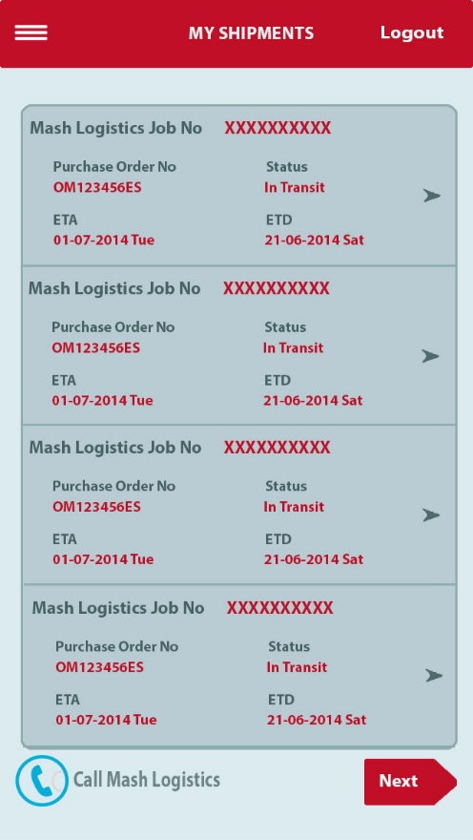

View order details

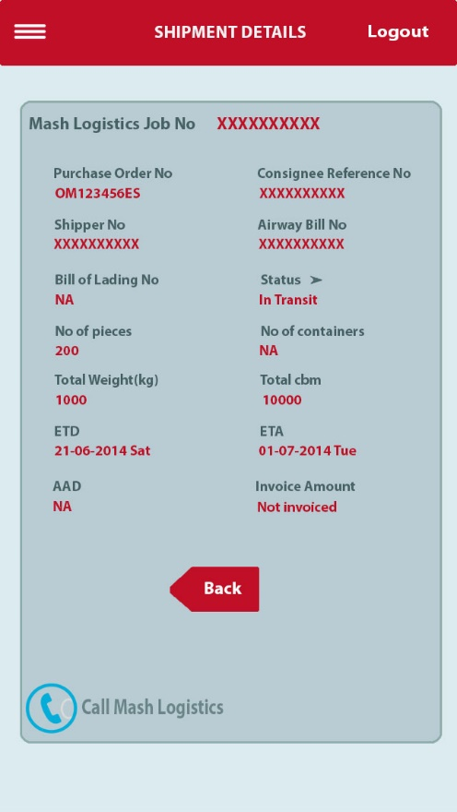

View status history in details

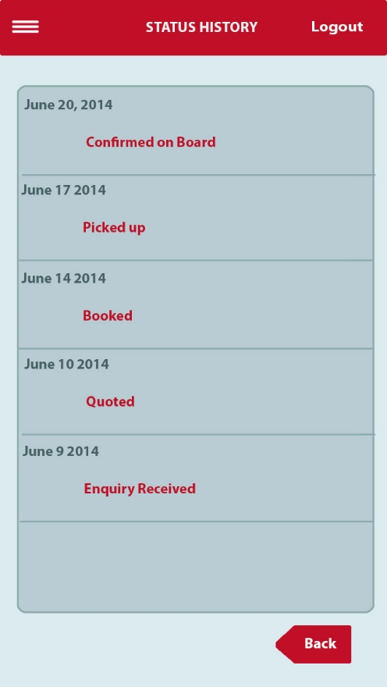

Data Definition

|  |  |  |  |  |  |  |  |  |  |
| --- | --- | --- | --- | --- | --- | --- | --- | --- | --- |
| **Data**  **Entity** | | **Data**  **Attribute** | | **Data**  **Type** | **Use Case(s)** | **Use Case Step(s)** | **Criticality** | **Status** | **Phase** |
|  | Username | |  | | AUC-001 | 3 | H |  | 1 |
|  | Password | |  | | AUC-001 | 4 | H |  | 1 |
|  | Mash Logistics Job No | |  | | AUC-002 | 3 and 7 | H |  | 1 |
|  | Purchase Order No | |  | | AUC-002 | 3 and 7 | H |  | 1 |
|  | Consignee Reference No | |  | | AUC-002 | 3 and 7 | H |  | 1 |
|  | Shipper Reference No | |  | | AUC-002 | 3 and 7 | H |  | 1 |
|  | Airway Bill No | |  | | AUC-002 | 3 and 7 | H |  | 1 |
|  | Bill of Lading No | |  | | AUC-002 | 3 and 7 | H |  | 1 |
|  | Shipment Status | |  | | AUC-002 | 3 and 7 | H |  | 1 |
|  | Estimated Time of Departure | |  | | AUC-002 | 3 and 7 | H |  | 1 |
|  | Estimated Time of Arrival | |  | | AUC-002 | 3 and 7 | H |  | 1 |
|  | No of pieces | |  | | AUC-002 | 7 | H |  | 1 |
|  | No of containers | |  | | AUC-002 | 7 | H |  | 1 |
|  | Total weight | |  | | AUC-002 | 7 | H |  | 1 |
|  | Tota cbm | |  | | AUC-002 | 7 | H |  | 1 |
|  | Actual arrival at destination | |  | | AUC-002 | 7 | H |  | 1 |
|  | Invoice Amount | |  | | AUC-002 | 7 | H |  | 1 |

# Freight Updater

Business Use Cases

Ability for vendor to update Freight status

Description

|  |  |  |  |  |  |  |
| --- | --- | --- | --- | --- | --- | --- |
| **Use Case Identifier** | BUC-002 | | | | | |
| **Use Case Type** | Business Use Case | | | | | |
| **Use Case Goal** | Ability for vendor to update Freight Status | | | | | |
| **Use Case Goal Level** |  | Summary |  | User Goal |  | SubFunction |
| **Actor(s)** | Mash Logistic Vendor [Primary Actor] | | | | | |
| **Triggering Event(s)** | Vendor accesses Freight Updater app to update Freight status | | | | | |
| **Pre-Condition(s)** | Vendor has already installed Freight Updater app from App store or Google play store or Mash website | | | | | |
| **Success End Condition(s)** | Vendor updates status for his/her assigned freights | | | | | |
| **Failed End Condition(s)** | Vendor is not able to update status for his/her assigned freights | | | | | |

|  |  |
| --- | --- |
| **Summary Narrative** | Vendor accesses Freight Updater mobile application using the credentials provided by Mash Logistics. The mobile app displays all the Freights assigned to the vendor by Mash Logistics. Vendor can update the status of each assigned Freight through the mobile application. |

Primary Scenario

|  |  |  |
| --- | --- | --- |
| **Description** | | **Change**  **(Y/N)** |
| **1** | Vendor logs in to Freight Updater mobile application | N |
| **2** | Vendor views list of Freights assigned to him/her | N |
| **3** | Vendor views details of selected freight | N |
| **4** | Vendor updates the status of Freights assigned to him/her | N |
| **5** | Vendor logs out of Freight Updater mobile application | N |

Supplemental Information

|  |  |
| --- | --- |
| **Application(s) Expected to be used by Actor** | Freight Updater Mobile application |
| **Business Capability** | Ability for vendors to update Freight Status |

Application Use Cases

Login to Freight Updater

Description

|  |  |  |  |  |  |  |
| --- | --- | --- | --- | --- | --- | --- |
| **Use Case Identifier** | AUC-003 | | | | | |
| **Use Case Type** | Application Use Case | | | | | |
| **Use Case Goal** |  | Summary |  | User Goal |  | SubFunction |
| **Actor(s)** | Mash Logistics Vendor | | | | | |
| **Pre-Condition(s)** | Vendor has already installed Freight Updater app from App store or Google play store or Mash website | | | | | |
| **Triggering Event(s)** | Vendor accesses Freight Updater to update status of assigned Freights | | | | | |
| **Success End Condition** | Vendor is able to successfully login to Freight Updater app | | | | | |
| **Failed End Condition** | Vendor is not able to successfully login to Freight Updater app | | | | | |

|  |  |
| --- | --- |
| **Summary Narrative** | Vendor has already downloaded/installed the Freight Updater application in their iPhone/iPad/Android. Vendor would like to access the Freight Updater app to update status of assigned Freights. Vendor selects the Freight Updater app icon on the home screen of the device. The login screen of the application is displayed and prompts the user to enter username and password. The username and password are provided by Mash Logistics to the vendor. If the correct combination of username and password are entered, the vendor will be able to successfully login to the application. If the combination of username and password is incorrect, the vendor will not be able to login to the application. The vendor can get in touch with Mash Logistics agent through the app using ‘Quick Call’ feature if required. |

Primary Scenario

|  |  |  |
| --- | --- | --- |
| **Step** | **Description** | **Chg. (Y/N)** |
| **1** | Vendor selects the Freight Updater app on the home screen of his/her iPhone/iPad/Android. | N |
| **2** | Vendor views the login screen and is prompted to enter the username and password to login. | N |
| **3** | Vendor enters the username | N |
| **4** | Vendor enters the password | N |
| **5** | Vendor submits the information | N |
| **6** | If the login credentials are correct, vendor successfully logs in to the application. | N |

Alternate Scenario (1)

|  |  |  |
| --- | --- | --- |
| **Step** | **Description** | **Chg. (Y/N)** |
| **1** | Vendor gets in touch with Mash Logistics agent through the app using ‘Quick Call’ feature if required. (Need to check with SME if they really need this option) | N |
| **2** | Vendor selects Quick call option. | N |
| **3** | App initiates a Phone call to Mash Logistic Agent. | N |

Alternate Scenario (2)

|  |  |  |
| --- | --- | --- |
| **Step** | **Description** | **Chg. (Y/N)** |
| **1** | Vendor selects the Freight Updater app on the home screen of his/her iPhone/iPad/Android. | N |
| **2** | Vendor views the login screen and is prompted to enter the username and password to login. | N |
| **3** | Vendor enters the username | N |
| **4** | Vendor enters the password | N |
| **5** | Vendor submits the information | N |
| **6** | If the login credentials are incorrect, vendor will not be able to log in to the application. A message is displayed “ Please contact Mash Logistics” | N |
| **7** | Vendor can get in touch with Mash Logistics Agent with the Quick Call feature if required. | N |
| **8** | Vendor selects Quick call option. | N |
| **9** | App initiates a Phone call to Mash Logistic Agent. | N |

Exception

|  |  |  |
| --- | --- | --- |
| **Step** | **Description** | **Chg. (Y/N)** |
|  |  |  |

Supplemental Information

|  |  |
| --- | --- |
| **Application(s) Expected to be used by Actor** | Freight Updater Mobile Application |
| **Business Capability** | Ability for Vendor to update Freight status |

Login

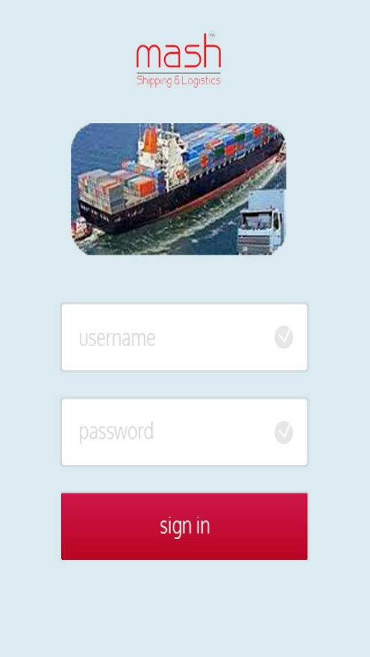

View assigned freights

Description

|  |  |  |  |  |  |  |
| --- | --- | --- | --- | --- | --- | --- |
| **Use Case Identifier** | AUC-004 | | | | | |
| **Use Case Type** | Application Use Case | | | | | |
| **Use Case Goal** |  | Summary |  | User Goal |  | SubFunction |
| **Actor(s)** | Mash Logistics Vendor | | | | | |
| **Pre-Condition(s)** | Vendor has already logged in to the Freight Updater app | | | | | |
| **Triggering Event(s)** | Vendor accesses Freight Updater to update Freight status | | | | | |
| **Success End Condition** | Vendor is able to successfully view his/her assigned orders in list view | | | | | |
| **Failed End Condition** | Vendor is not able to successfully view his/her assigned orders in list view | | | | | |

|  |  |
| --- | --- |
| **Summary Narrative** | Vendor has already logged in to the Freight Updater application. Vendor view his/her assigned freights in list view. For each assigned freight, vendor views the following details. If vendor wishes to view details of each freight, he/she can select view details. The vendor is then navigated to view the details of the selected freight. Details which are not available will be displayed as ‘NA’. If the customer would like to view the status history, the customer can select option to view status history. |

Primary Scenario

|  |  |  |
| --- | --- | --- |
| **Step** | **Description** | **Chg. (Y/N)** |
| **1** | System identifies all the freights assigned to the vendor based on the login credentials. | N |
| **2** | Sytem sorts the list of freights based on Mash Logistics Job No. | N |
| **3** | System displays sorted freights in list view to the vendor with the following information.   * Mash Logistics Job No * Vendor Job No * Purchase Order No/Consignee Reference No/ Shipper Reference No (Whichever is available. If all three numbers are available, then Purchase Order No will be displayed) * Status (Last status only will be displayed) * Estimated Time of Departure (ETD) * Estimated Time of Arrival (ETA) | N |
| **4** | Vendor can select view freight details if he/she wishes to view detailed information for each freight | N |
| **5** | On selecting view details, vendor is the navigated to the details page. | N |
| **6** | System displays the details of the selected freight. | N |
| **7** | The details of the shipment are as follows:   * Mash Logistics Job No * Vendor Job No * Purchase Order No * Consignee Reference No * Shipper Reference No * Airway Bill No (if mode of shipment is air) * Bill of Lading (if mode of shipment is sea) * Status of the shipment (History of all statuses for this shipment will be shown in this page. See appendix M for more details) * No of pieces/container depending upon shipment mode (air, sea respectively) * Total Weight * Total CBM (cubic meter) * Estimated Time of Departure * Estimated Time of Arrival * Actual arrival at Destination * Invoice Amount (if invoiced ) | N |

Alternate Scenario(s)

|  |  |  |
| --- | --- | --- |
| **Step** | **Description** | **Chg. (Y/N)** |
| **1** | Vendor may choose to go to the list view page where he can view a summary of all the shipments from the details page by selecting the ‘Back’ option | N |
| **2** | Vendor may choose to logout of the application from the list view page or from the details page | N |

Exception(s)

|  |  |  |
| --- | --- | --- |
| **Step** | **Description** | **Chg. (Y/N)** |
| **1** | Vendor is not able to view his/her assigned freights in list view | N |

Supplemental Information

|  |  |
| --- | --- |
| **Application(s) Expected to be used by Actor** | Freight Updater Mobile Application |
| **Business Capability** | Ability for Vendor to update Freight Status |

View Assigned Shipments

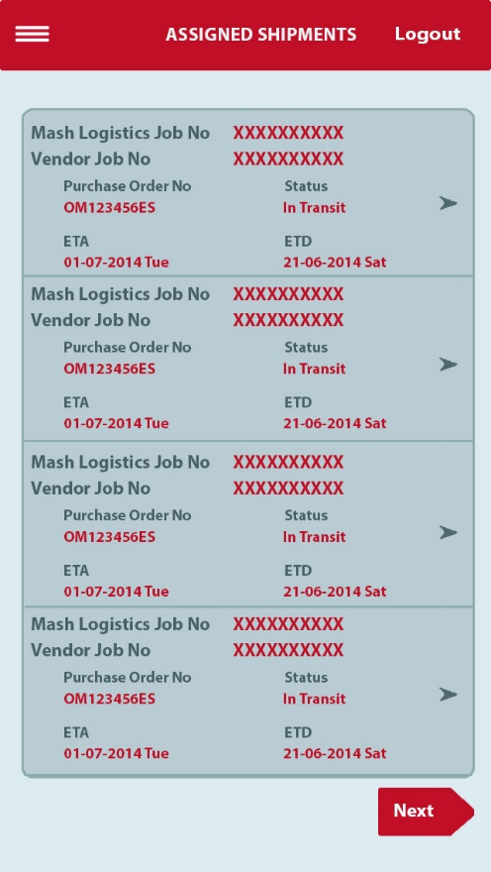

View Shipment Details

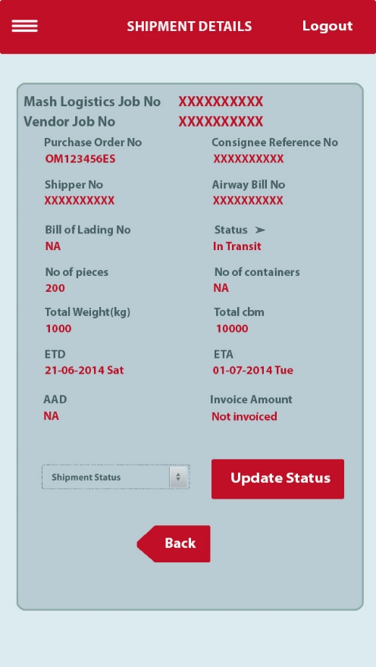

View status history in details



View updated details page

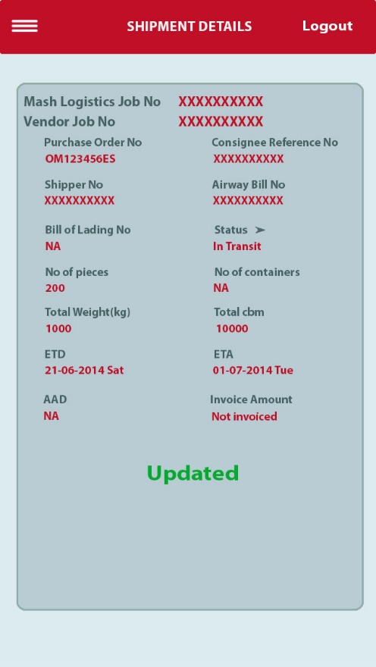

Data Definition

The following new data attributes are being introduced in the context of functional capabilities being requested.

|  |  |  |  |  |  |  |  |  |  |
| --- | --- | --- | --- | --- | --- | --- | --- | --- | --- |
| **Data**  **Entity** | | **Data**  **Attribute** | | **Data**  **Type** | **Use Case(s)** | **Use Case Step(s)** | **Criticality** | **Status** | **Phase** |
|  | Username | |  | | AUC-003 | 3 | H |  | 1 |
|  | Password | |  | | AUC-003 | 4 | H |  | 1 |
|  | Mash Logistics Job No | |  | | AUC-004 | 3 and 7 | H |  | 1 |
|  | Vendor Job No | |  | | AUC-004 | 3 and 7 | H |  | 1 |
|  | Purchase Order No | |  | | AUC-004 | 3 and 7 | H |  | 1 |
|  | Consignee Reference No | |  | | AUC-004 | 3 and 7 | H |  | 1 |
|  | Shipper Reference No | |  | | AUC-004 | 3 and 7 | H |  | 1 |
|  | Airway Bill No | |  | | AUC-004 | 3 and 7 | H |  | 1 |
|  | Bill of Lading No | |  | | AUC-004 | 3 and 7 | H |  | 1 |
|  | Shipment Status | |  | | AUC-004 | 3 and 7 | H |  | 1 |
|  | Estimated Time of Departure | |  | | AUC-004 | 3 and 7 | H |  | 1 |
|  | Estimated Time of Arrival | |  | | AUC-004 | 3 and 7 | H |  | 1 |
|  | No of pieces | |  | | AUC-004 | 7 | H |  | 1 |
|  | No of containers | |  | | AUC-004 | 7 | H |  | 1 |
|  | Total weight | |  | | AUC-004 | 7 | H |  | 1 |
|  | Tota cbm | |  | | AUC-004 | 7 | H |  | 1 |
|  | Actual arrival at destination | |  | | AUC-004 | 7 | H |  | 1 |
|  | Invoice Amount | |  | | AUC-004 | 7 | H |  | 1 |

# Non Functional Requirements

Non-Functional Requirements List

(Need more information – have sent Questionnaire)

|  |  |  |  |  |
| --- | --- | --- | --- | --- |
| **Req**  **ID #** | **Non-Functional Requirement** | **NF Type** | **Use Case** | **Use Case**  **Step** |
|  |  |  |  |  |

# Business Rules List

Not identified yet

| **Rule ID #** | **Business Rule** |
| --- | --- |
|  |  |

# Information Usage Requirements

None identified

# Design Considerations

None identified

# Testing Considerations

Need more information

|  |
| --- |
| **Scenarios & Capabilities** |
|  |

# Appendix

1. Glossary of Terms and Acronyms

This subsection should provide the definitions of all terms, acronyms, and abbreviations required to properly interpret the document. This information may be provided by reference to the project Glossary.

| **Term** | **Definition** |
| --- | --- |
| Consignee | The person to whom the shipment is to be delivered whether by land, sea or air. |
| Freight | Goods transported in bilk by truck, train, air or ship. |

1. Release Planning

### *Project Phases*

|  |  |
| --- | --- |
| **Phase** | **Phase Description** |
| 1 | Automate Freight Tracking – Ability for customers to view Freight Status and Ability for vendors to update Freight Status |
|  |  |

1. Traceability

Business Objectives to Business Capabilities Mapping

| **Business Objectives in support of Company Goals** | **Business Capabilities**  **Required to accomplish Objective** | **Dependencies between Capabilities** | **Added / Changed since IA?** |
| --- | --- | --- | --- |
| 1. Automate Freight Tracking | 1. Ability for customers to view Freight Status |  | No |
| 1. Ability for vendors to update Freight Status |  | No |

1. Freight forwarding process (Import or Export)

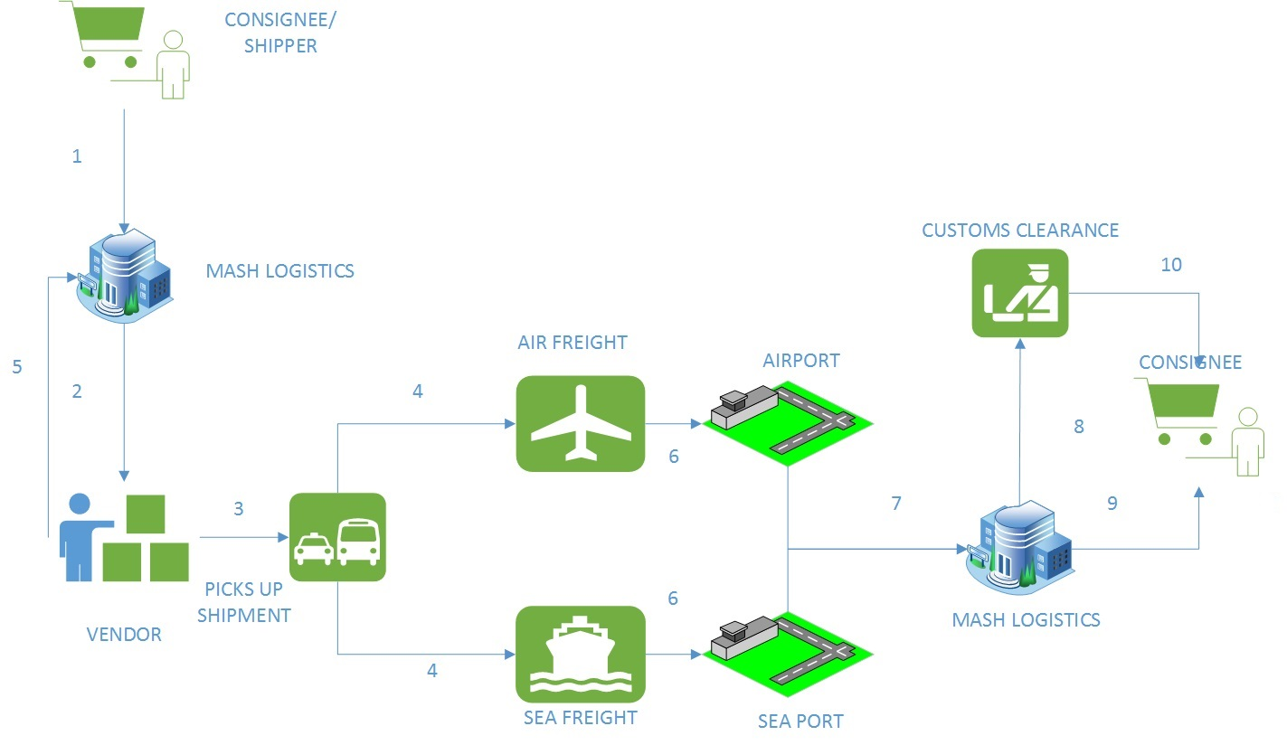

* 1. Consignee/Shipper books shipment with Mash Logistics. The customer is given the Mash Job No. Status of shipment is updated as ‘Booked’.
  2. Mash Logistics contacts vendor for pick up and handling.
  3. Shipment is picked up by Vendor. Status of shipment is updated as ‘Picked up’.
  4. Once the shipment is in the flight/sea vessel, the vendor updates the status of the shipment as ‘Confirmed on Board’.
  5. The vendor then receives the Airway bill no (mode of shipment is air) or Bill of Lading no (mode of shipment is sea) and sent the related documents together with the Airway bill no/Bill of Lading no to Mash Logistics.Then the vendor updates the status of shipment as ‘Console Document Sent’ (CDS). When Mash Logistics receives the documents, the status is updated by Mash Logistics as ‘Console Document Received’ (CDR). (CDR and CDS statuses not shown to customer).
  6. When the shipment is on route to Saudi Arabia, the shipment will be in ‘in transit’ status.
  7. Once the shipment has reached Saudi Arabia, the status of the shipment is updated by Mash Logistics as ‘arrived’.
  8. If Mash Logistics handles Customs operations also, the status of the shipment is updated to ‘Entry filed to customs’. Upon successful clearance, the shipment status is updated as ‘Released from customs’.
  9. If Mash Logistics does not handle Customs operations (happens 99% of the time when exporting from Saudi to other countries), then the shipment is handed over to customer/broker on arrival at the destination port. Documents are turned over to the consignee and then updated as Freight Released.
  10. Once customs operations are successfully handled by Mash Logistics, the shipment is handed over to consignee at the port and the status of the shipment is updated as ‘Delivered’. Upon delivery, the shipment is invoiced and status is updated as ‘Invoiced’. But this status is not shown to customer. This is only shown to the vendor. The last status of a shipment that will be displayed to the customer is ‘delivered’.

1. Shipment statuses displayed in Freight Tracker mobile application

Following are the statuses for every freight order that will be displayed to the customer

1. Booked
2. Picked up
3. Confirmed on Board
4. In transit
5. Arrived

If Mash Logistics handles customs clearance at the destination port,

1. Arrived
2. Entry filed to customs
3. Released from customs
4. Delivered

If Mash Logistics does not handle customs clearance at the destination port,

1. Arrived
2. Document turned over to customer/broker
3. Freight released
4. Shipment statuses displayed in Freight Updater mobile application

Following are the statuses for every freight order that will be displayed to the vendor

* 1. Booked
  2. Picked up
  3. Confirmed on Board
  4. Console Document Sent
  5. Console Document Received
  6. In transit
  7. Arrived

If Mash Logistics handles customs clearance at the destination port,

1. Arrived
2. Entry filed to customs
3. Released from customs
4. Delivered

If Mash Logistics does not handle customs clearance at the destination port,

1. Arrived
2. Document turned over to customer/broker
3. Freight released